Start
Work out what YOU want to be found for…
https://ads.google.com.au > Keyword Planner
Search Phrase | Searches per month | Notes: Competition, Map? etc

Use your words!
Page titles 50-60 characters Up to 120 characters on your front page title

https://www.semrush.com/blog/on-page-seo-basics-page-titles
Page descriptions two short sentences 160 characters

Exercise: Write a better front page title for your website!

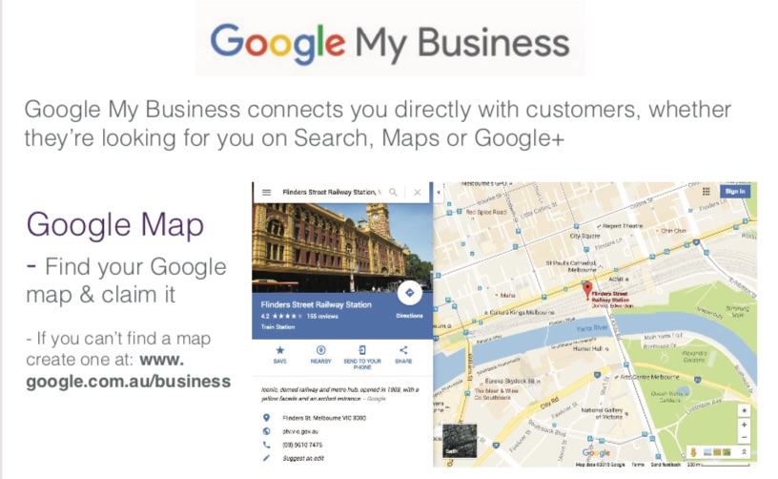

Google MyBusiness
www.google.com.au/business

Content Marketing for SEO

https://moz.com/beginners-guide-to-content-marketing

- Who are your Dream Clients?
- What do they Need, Value or Search for?
- What’s your “Pitch”?
Content Calendar – Plan the “Who, what and when” for developing your content

Small Business Vic - Content Marketing planning templates
https://business.vic.gov.au/business-information/marketing-and-sales/write-a-content-marketing-plan

https://docs.google.com/spreadsheets/d/1nVE90ijlJt5Vq2cHSFSlTb7NywrTiO25UOkXDht_hPU/edit#gid=0

Website Speed

Page Speed Insights - Google’s own test
https://developers.google.com/speed/pagespeed/insights/

GT Metrix - Detailed test, Aust option, PDF reports
https://gtmetrix.com

Google’s “Web Vitals” score
- First Contentful Paint – Can I see it?
- Time To Interactive – Can I use it?
- Cumulative Layout Shift – Has it stopped “wiggling”?

Setup Google Account
Simply an email and password to login to all Google services
You will need this to setup Google Alerts, add your business to Google Maps / MyBusiness and connect Google Analytics to your website
- Visit e.g. Google Analytics > Create account
- Do Use your business email (strongly suggest to use your primary business email address to create a Google account as its much less likely to be forgotten than a Gmail email)
- Do Record your Google account login details safely

Links
SEO Guides
https://moz.com/beginners-guide-to-seo
https://developers.google.com/search/docs/beginner/get-started

Google Analytics
Search for “Google analytics” or visit https://analytics.google.com

Google Ads: Get Started and Beginner Guides
https://ads.google.com/home/
https://support.google.com/google-ads/
https://www.wordstream.com/learn

Other Useful Tools
Answer the Public - Great for content ideas
https://answerthepublic.com/
Mailchimp – email marketing
mailchimp.com

Digital Safety Check!

https://www.artful.com.au/web/digital-safety-check.html

NOTES

This handout and workshop content have been developed by Nick Sibbing from Artful Web+Print+Design © Artful 2021

Important Disclaimer
All information in this handout and associated presentation is provided for general guidance and assistance only and is not intended as advice. You should make your own inquiries as to the appropriateness and suitability of the information provided. Every effort has been made to ensure information is correct. However, no claim is made as to the currency, accuracy or completeness of the content. BizHub, Maroondah Council and the authors and presenters do not accept any liability for the information or the use of the information in the handout and associated presentations.

